How Do I Serve the Restrained Person with my Petition for a Protection Order?
What is “proof of service” and why does it matter?
Service is the act of giving legal papers to someone. Service is how the other party formally learns about the case and lets the court know they can begin making decisions that affect that person (this is called personal jurisdiction).
The law requires that all parties have a fair chance to go to their hearings and to receive all evidence that the court sees. The restrained person must be served with a petition and notice of the hearing (usually contained in the temporary order). If the restrained person is not served correctly, the court cannot decide the case until they are served correctly. Also, a protection order cannot be enforced unless the restrained person knows about it. You must prove that the restrained person was properly given the petition, notice of hearing, temporary order, and Order to Surrender and Prohibit Weapons, if applicable, and all evidence that you want the court to review. If you don’t, your case can be delayed or even dismissed.
After the restrained person is served the petition and temporary order(s), either party may file more evidence they want the court to consider. All parties have a right to see what the other party gave to the court. It is usually okay to serve this additional evidence by electronic or mail service.
Deadline! Protection orders must be served at least 5 court days before the hearing. For example, if your hearing is on a Friday and there are no holidays, papers must be served by Friday the week before. Weekends and holidays do not count towards the 5 days. Check with your court clerk for more information on deadlines.
What form do I use?
The form is called “Proof of Service.” This form can be used for all protection order cases except for Extreme Risk Protection Orders. You can find the Proof of Service form on the Washington Court Forms website here: http://www.courts.wa.gov/forms/. You can also search the internet for the form title, “PO 004 Proof of Service,” or ask the court clerk for help.
Who fills out the form?
The person who served the legal papers (the server) must complete the Proof of Service form. The person who started the case (the petitioner) cannot serve the petition and temporary order on the restrained person. The server must be over the age of 18. The server may be a police officer, Sheriff’s deputy, other law enforcement officer, professional service provider, or any adult whom you trust to do it right and fill out the proof of service.
What are the different ways to serve legal papers?
1. Personal Service – The server hands the legal papers directly (in-person) to the person being served. This is the best kind of service and should be done whenever possible for the petition and temporary order(s).
2. Electronic Service – The server sends the legal papers by email, text, social media, or other technology. Electronic service can be okay. However, do not use electronic service for a petition and temporary order if any of these are true:
- the restrained person is in jail or prison
- the court ordered the restrained person to surrender firearms
- the court ordered transfer of child custody
- the court ordered the restrained person to leave the residence that they share with the protected person
- the petition for a vulnerable adult protection order is filed by someone other than the vulnerable adult
For cases involving a restrained person who is in jail or prison, the surrender of firearms, the transfer of child custody or that requires the restrained person to leave the shared residence, only law enforcement can personally serve the petition and temporary order.
For cases involving a petition for a vulnerable adult protection order that is filed by someone other than the vulnerable adult, the petitioner can choose to have someone else serve the petition, temporary order, and notice to the restrained person. The court must allow electronic service in these cases after 2 unsuccessful attempts at personal service.
After the petition and temporary order are served, you may be able to use electronic service for any additional evidence that you want the court to review. If you are not sure if electronic service is allowed in this case, use personal service.
3. Service By Mail – For the petition and temporary order, you can ask the court to allow service by mail. Do not serve a petition and temporary order by mail unless you have a court order saying it is okay. The Order to Allow Service by Mail (form PO 025) has instructions for how to serve by mail.
For evidence filed after the petition is served, you can always serve by mail.
4. Service By Publication – If you cannot serve the restrained person in any other way, you can ask the court to allow service by publication in a newspaper. This costs money and takes more time. The Order for Service of Summons by Publication (form PO 026) has instructions for how to serve by publication. If you serve by publication, do not use the regular Proof of Service form. Instead, attach the newspaper’s proof that the Summons was published to the Proof of Publication (Cover Sheet) (form All Civil 036).
How Do I Fill Out the Proof of Service Form?
It is important to fill out the whole form. It is important to file this form in the court file even if the other party was not served. Make sure you file this form with the court clerk so the judge can see it and determine next steps for service in your case.
Caption. At the beginning of the form at the top, write the parties’ full names with middle initials, date of birth, and case number.
1. Write the server’s full name. The form needs to be filled out by the person who served the other party.
2. Able to Serve: If service was successful, check the box for the type of service used.
[ ] Personal Service: Write the name of the person who was served, and the date, time, and address where the service happened.
[ ] Electronic Service: Write the name of the person served and the date service happened. Check the method of electronic service by selecting email, text messaging, social media application, or other technology. Provide the address, number, and any account or username used.
For example: user@gmail.com for email, 206-555-5555 for text, or through Facebook at User Name.
Check whether a “read receipt” or other reply was received.
[ ] Service by Mail: Write the name of the person served and date the documents were mailed. Be sure to mail 2 copies, postage prepaid: one by ordinary, first-class mail and one by other mail with certified or tracking information. Write the address that it was sent to.
3. Not Able to Serve: If you are not able to serve the other party, explain all the ways that service was tried. Include dates and times. Check whether an attempt at electronic service “bounced back” or was “undeliverable.” Check whether you were not able to mail court documents because you did not know the party’s last known address.
4. List of Documents: The server must list every document served by checking the box by the name of each document that was served and by using the “Other documents” section to add the titles of any documents served that are not listed. The title of documents can be found on the right side of the caption in all forms. It is also repeated under the caption in most forms.
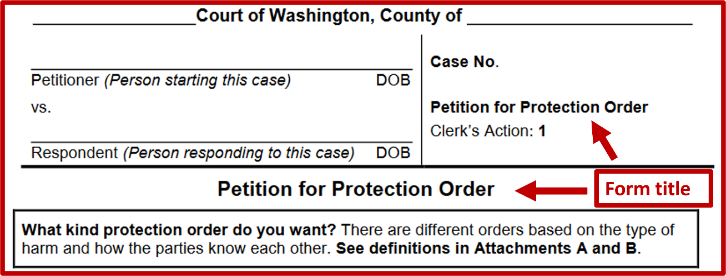
If every document served is not checked or listed on this form, service may be considered “incomplete” and will likely require other attempts at service. This can cause delay.
5. Fees Charged for Service: If you are a professional server, fill out this section about your fees.
6. Other: You can write anything else that the court should know about service. If service was not successful, write the reasons. For example, explain if the person was not at the location or the party moved. Also explain any concerning behavior of the restrained person at the time of service and any information they share about the possession of weapons, including any denials about firearm ownership/possession.
At the bottom of the form. Remember that the server, NOT the petitioner or respondent, must sign the form. It must be signed and sworn “under penalty of perjury” that the information in the form is true. In addition, the location of the server, the date of signing, and the server’s signature must be included at the bottom.

